SSH Key Creation :

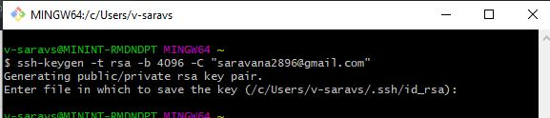

Add Public Key to git Account:

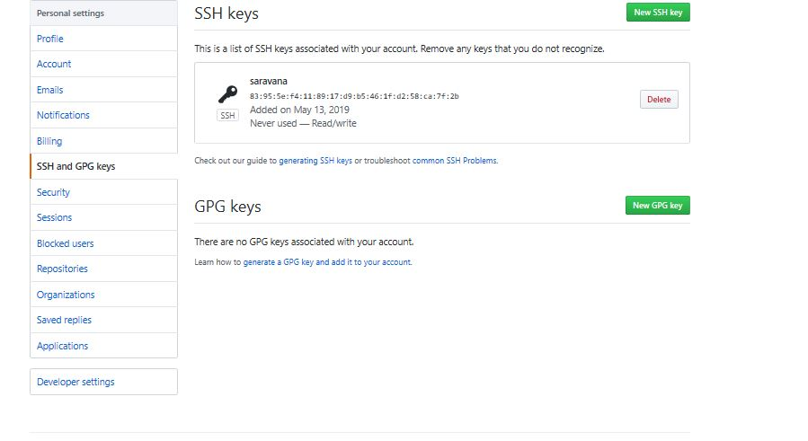

SSH key for access:

